**SMART WEATHER(WITH JIRA)**

**Q1)** Identify at least five epics and 15 user stories from the case above(use your interpretation and independent research). Link the stories to the epics.

Ans) The epics and user stories of smart weather are listed below:

**Epics**

1)**Registration of Users :**

a) The Smart Weather Web Portal must have facility for registration of both free and paid users.

b) The count of users in the portal should not be negative.

c) There must be a separate section of free and paid users

d) Details such as Sno,Name,Age,Gender and location of the users must be captured inside portal

2) **Location Detection:** The detection of weather,climate and temperature of different locations must be captured inside the Smart Weather Web Portal

3) **Registration of Satellite Images**

a) The Portal must have capacity for capturing satellite Images

b) The Portal must support images of .bitmap,jpg,.png formats

c) The length,breadth and width of the images can be enlarged or decreased according to user

requirement

4) **User Interface of Smart Weather Web Portal**

a)The UI or form design of web portal must be responsive

b) Developers can make use of HTML,CSS and JavaScript for designing web portal

c) The web portal must be dynamic and should be easy to navigate

5) **Creation of Android Mobile Apps**

a) An Android Mobile Application must be created for the Smart Weather Web Portal

b) The Android Smart Weather App must be easily available on the Google Play store for the android users

c) There won’t be any charges for first six months for Smart Weather App

6) **Creation of IOS Smart Weather Apps**

a)Apps must be created for IOS devices

b) The apps must be easily available on the App store

7) **Database Creation**

1. The database must be created on the basis of location
2. Their must be tables and views which contains information related to the number of paid and free web portal users as well as the other characteristics such as name, age and gender of the user in the schema

**User Stories**

1. Registration of free users on Smart Weather Web Portal-Linked it to registration of users
2. Registration of paid users on Smart Weather Web Portal-Linked it to registration of users
3. The smart weather web portal must also display the profile picture of paid users-Linked it to registration of users
4. The location detection is possible through GPS or IP address-Linked it to location detection
5. Information of current Weather ie Temperature in Centigrates must be visible inside the portal-Linked it to Registration of Satellite Images
6. The Smart Weather Web Portal must display the forecast for five,10 and 15 days at a location-Linked it to Registration of Satellite Images
7. Information related to seasonal forecast ie prediction of snowfall,rainfall must be visible in smart weather web portal-Linked it to Registration of Satellite Images
8. The time lapse Videos of satellite forecast must be visible in web portal-Linked it to registration of Satellite Images
9. The portal must be integrated with public weather services around the world-Linked it to User Interface of Smart Weather Web Portal
10. There must be provisions for various advertisements on Smart Weather Web Apps-Linked it to Creation of Android Mobile Apps
11. Android mobile apps of Smart Weather are divided in free and paid category-Linked it to Creation of Android Mobile Apps
12. Some Services must be assigned for android and ios mobile apps-Linked it to Android Mobile Apps and IOS mobile Apps
13. There must be provisions of advertisements for Android Mobile Apps-Linked it to Creation of Android Mobile Apps
14. There must be provisions of advertisements for IOS Mobile Apps-Linked it to Creation of IOS Mobile Apps
15. Schema needs to be created inside the database-Linked it to Database Creation

Q2) Get a free JIRA account and create a Scrum project.

Ans) Here are the screenshots of the Scrum Project

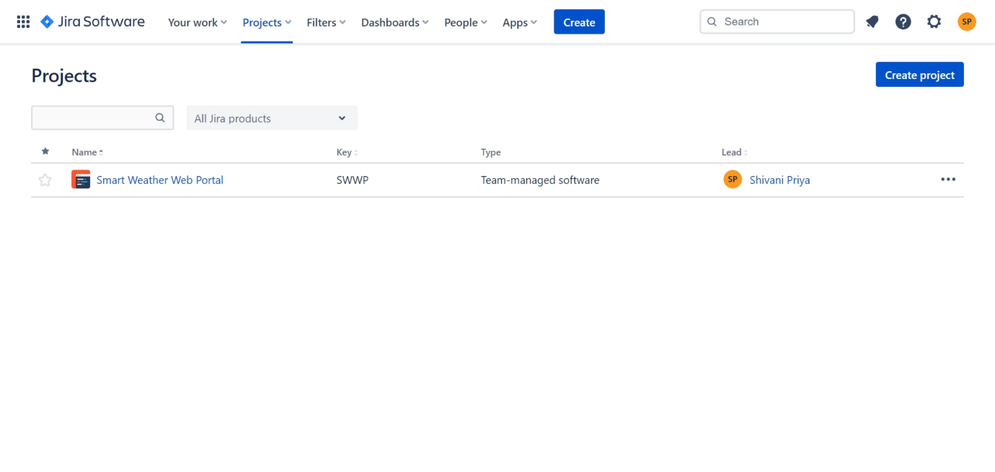

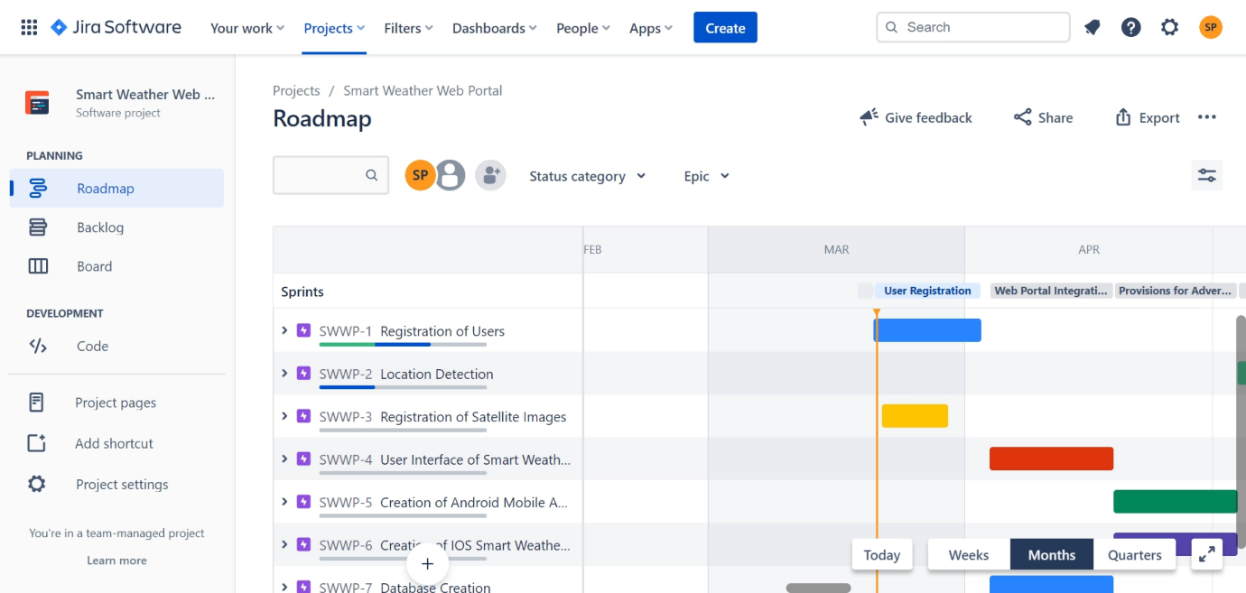

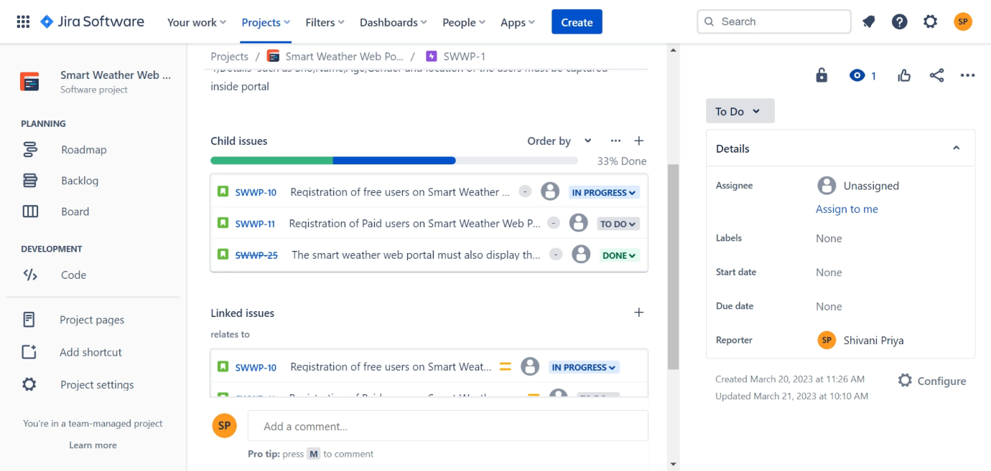



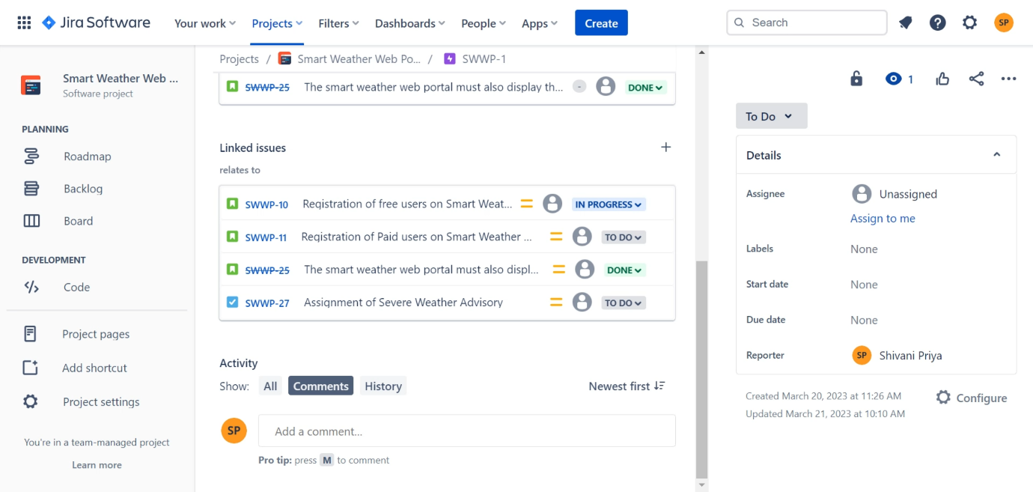

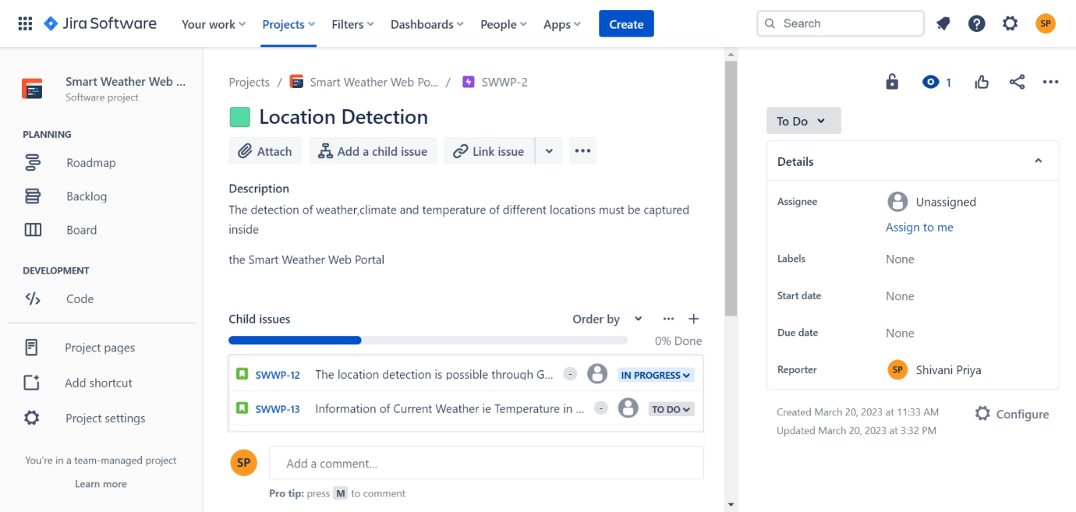

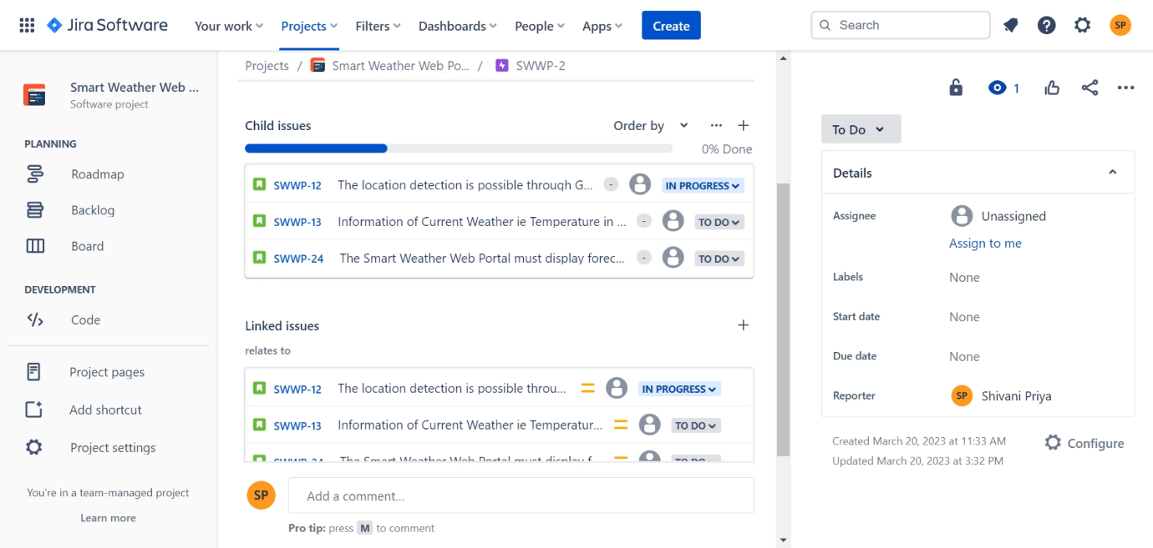

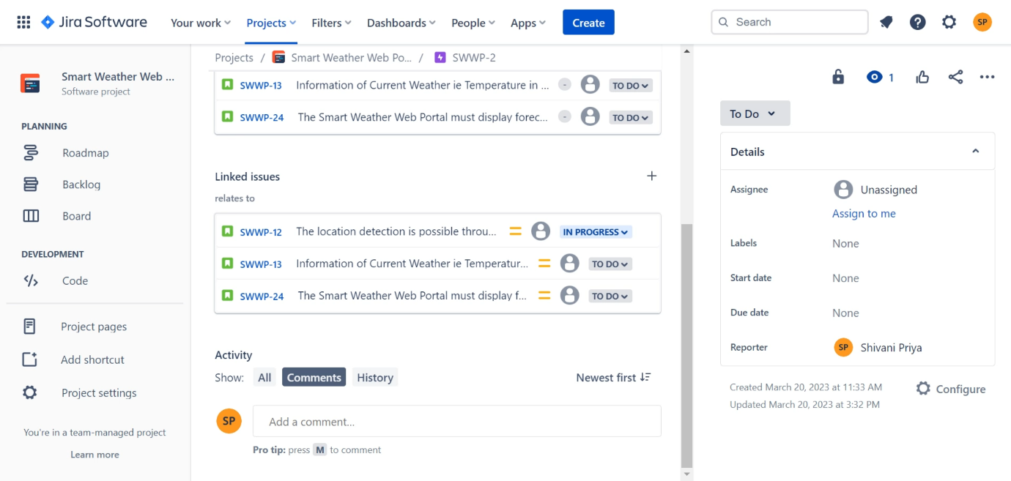

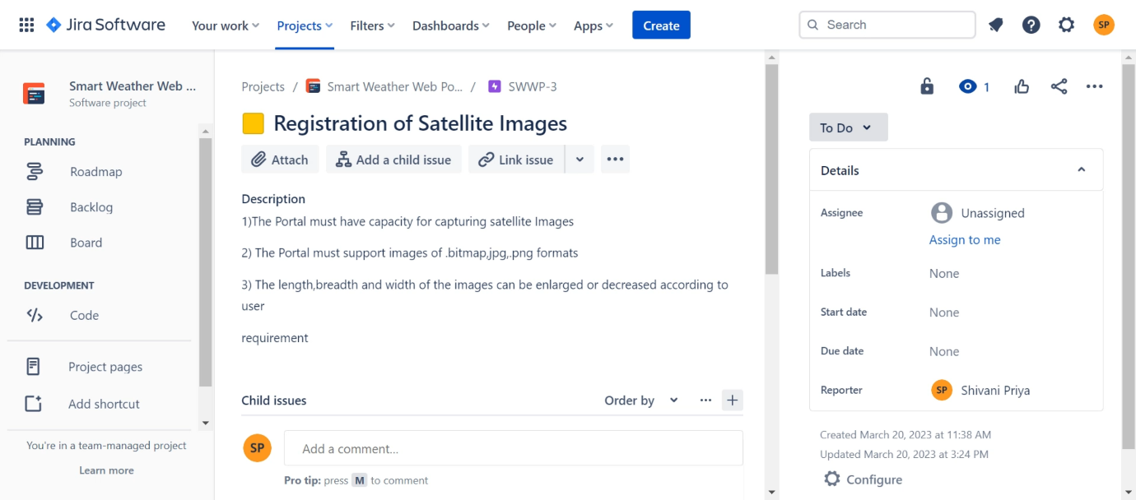

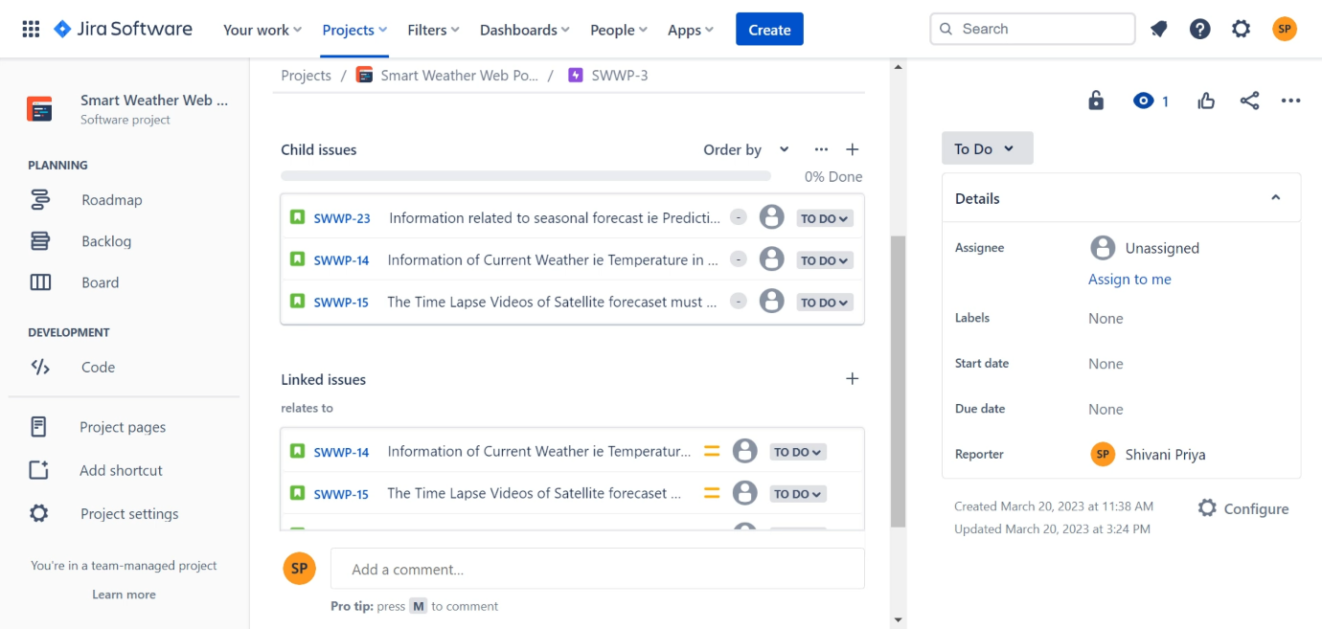

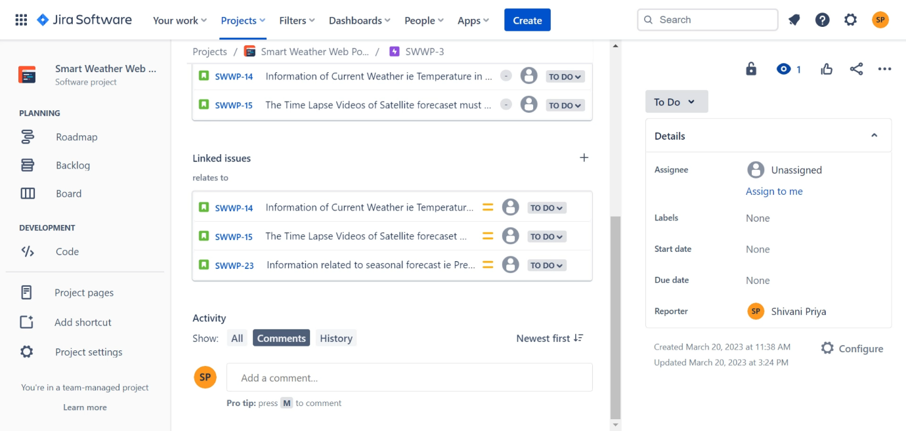

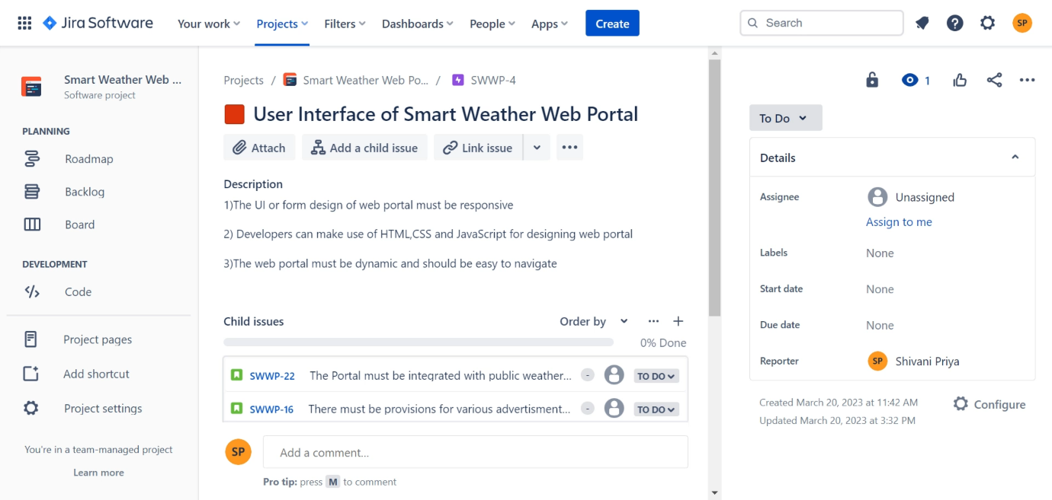

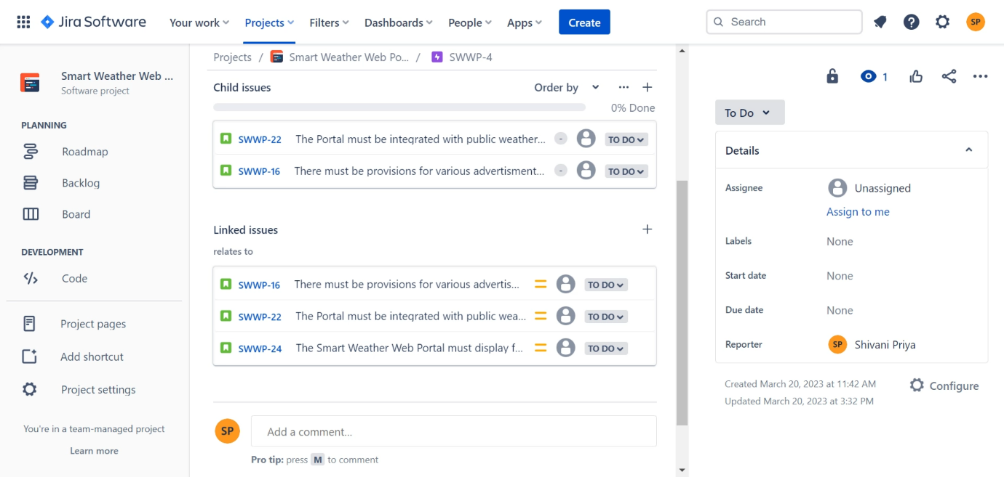

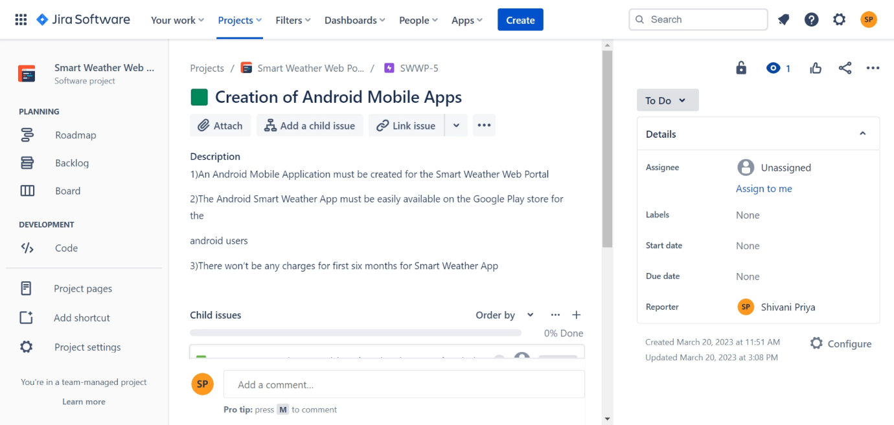

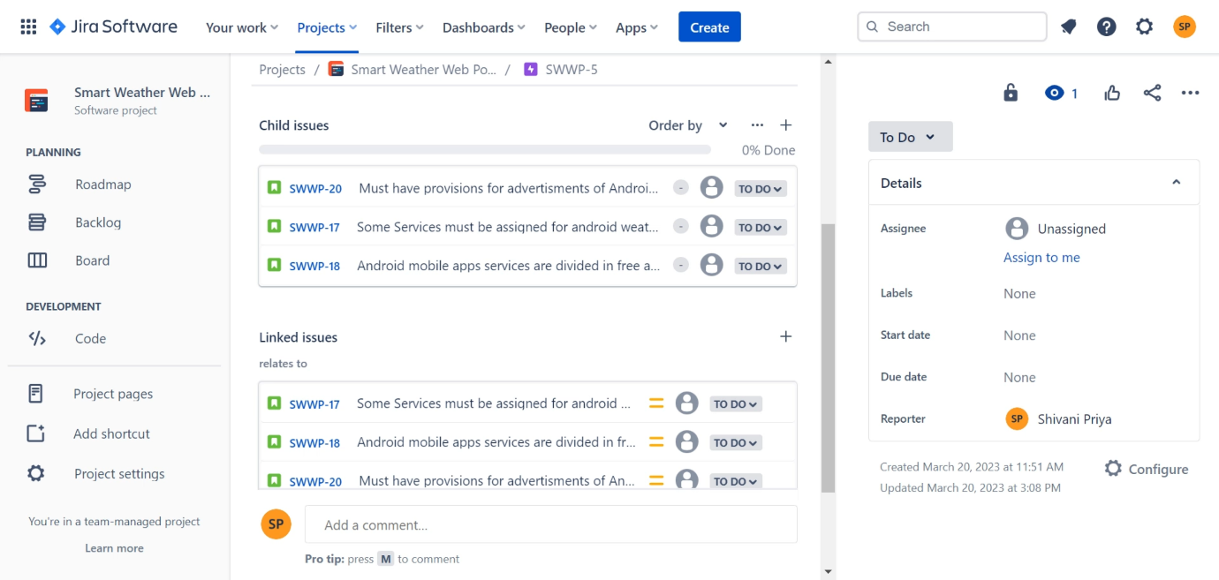

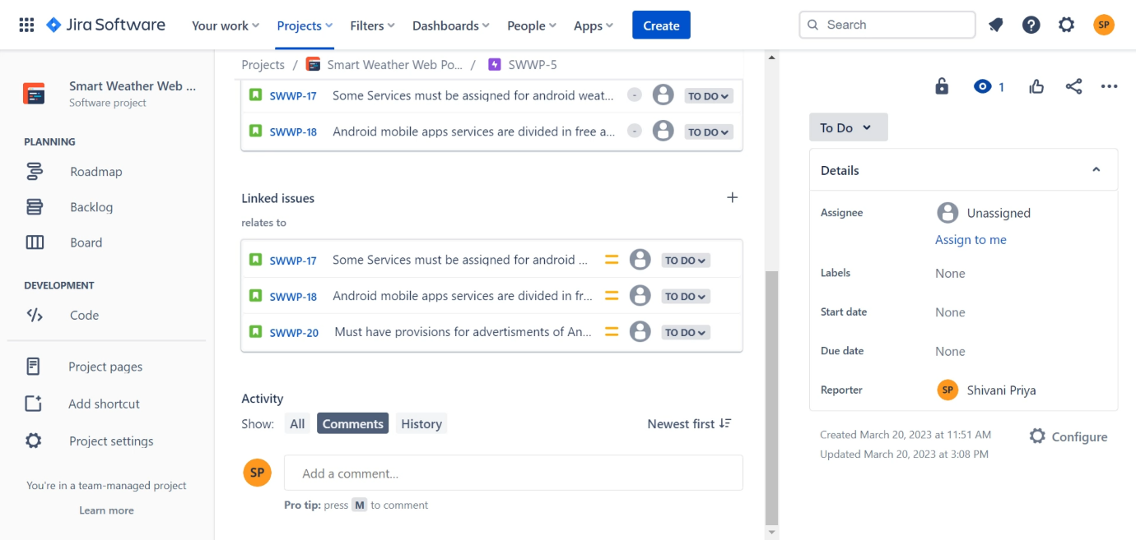

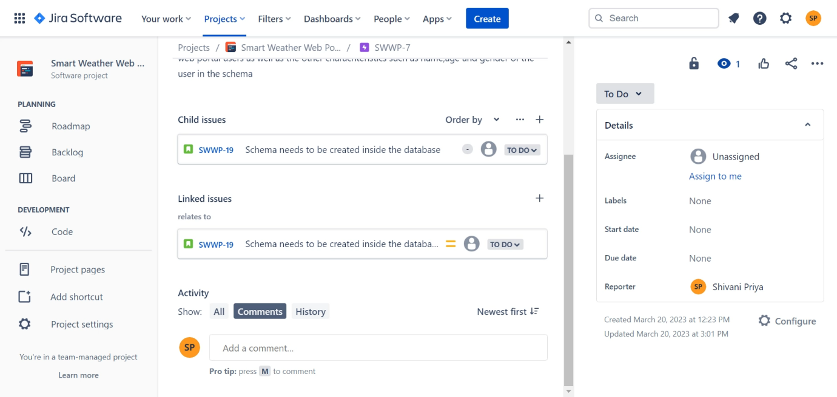

For detailed description of epics click on : <https://simplilearns.atlassian.net/jira/software/projects/SWWP/boards/2/roadmap>

For detailed description of backlog and user stories click on:

<https://simplilearns.atlassian.net/jira/software/projects/SWWP/boards/2/backlog>

For Sprint board description click on:

<https://simplilearns.atlassian.net/jira/software/projects/SWWP/boards/2>

Q3) Enter the backlog (epics, stories and subtasks) in JIRA.

Ans) The backlog view of JIRA is as follows:

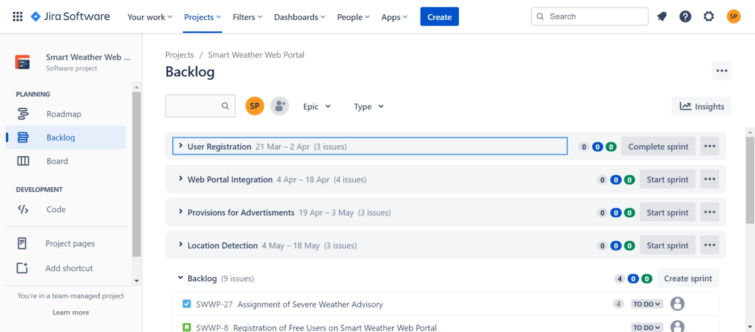

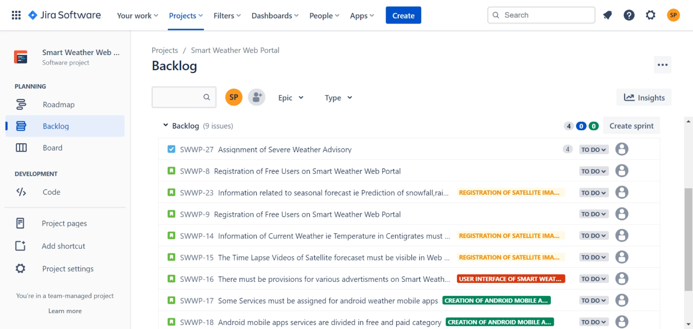

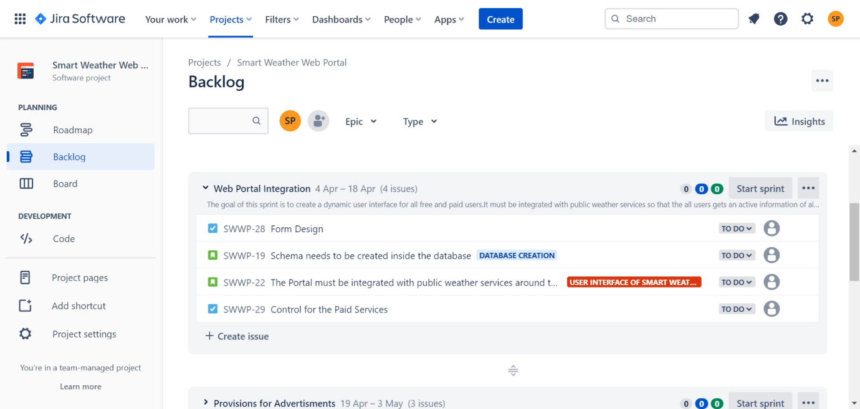

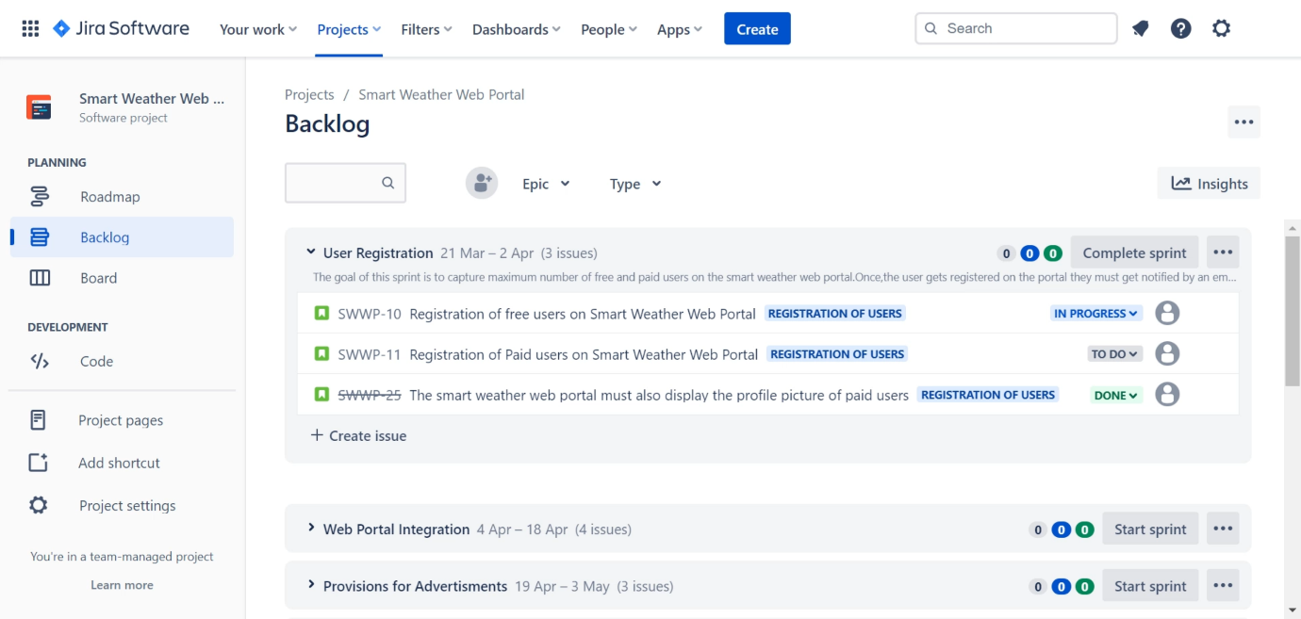

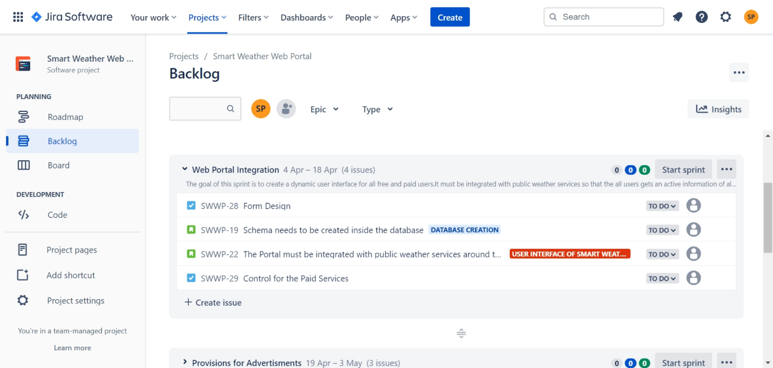

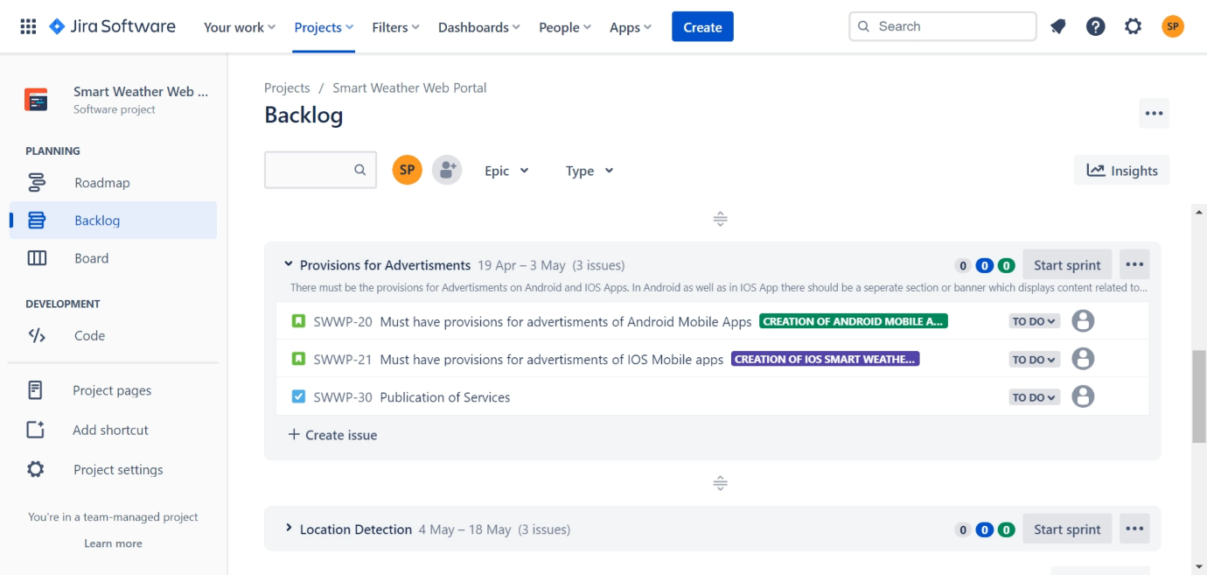

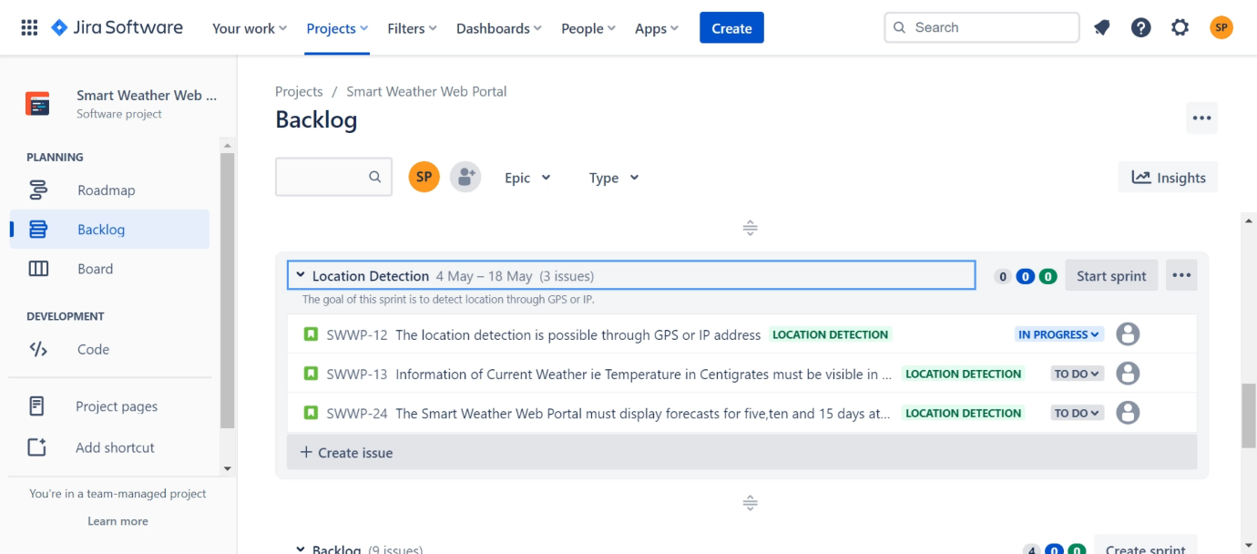

For detailed description of backlog click on

<https://simplilearns.atlassian.net/jira/software/projects/SWWP/boards/2/backlog>

The basic view of epic is as follows:



For detailed description of epics click on <https://simplilearns.atlassian.net/jira/software/projects/SWWP/boards/2/roadmap>

Q4) Make a tentative release plan, by assigning the stories to three sprints.

Ans) Here I am considering four sprints of smart weather. The first sprint is User Registration and its duration is from 21st March 2023 to 2nd April 2023. The second sprint is

Web Portal Integration and its duration is from 4th April 2023 to 18th April 2023.The third Sprint is Provision for Advertisements and its duration is from 19th April 2023 to 3rd May 2023 and the last one is Location Detection and its duration is from 4th May 2023 to 18th May 2023

|  |  |  |
| --- | --- | --- |
| S.No | Sprint Name | Release Plan(Duration) |
| 1 | User Registration | 21/03/2023 to 2/04/2023 |
| 2 | Web Portal Integration | 04/04/2023 to 18/04/2023 |
| 3 | Provisions for Advertisments | 19/04/2023 to 03/05/2023 |
| 4 | Location Detection | 04/05/2023 to 18/05/2023 |
|  |  |  |

The sprint view is as follows:

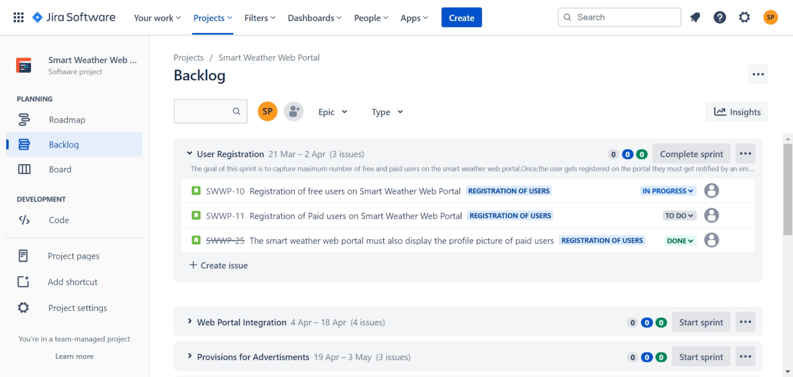

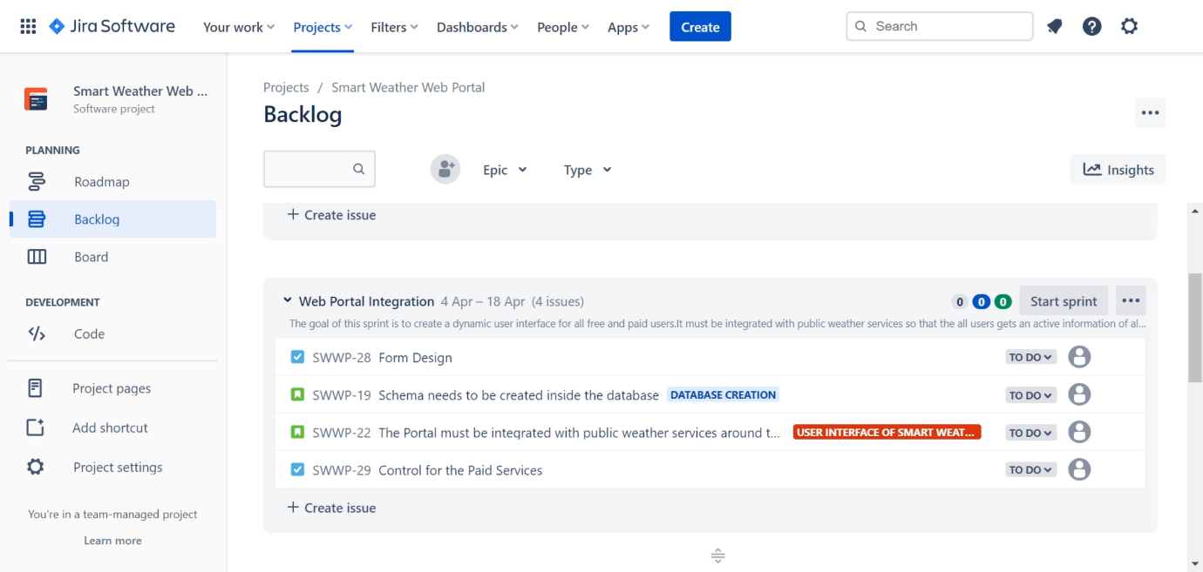

For detailed description of sprint click on <https://simplilearns.atlassian.net/jira/software/projects/SWWP/boards/2/backlog>

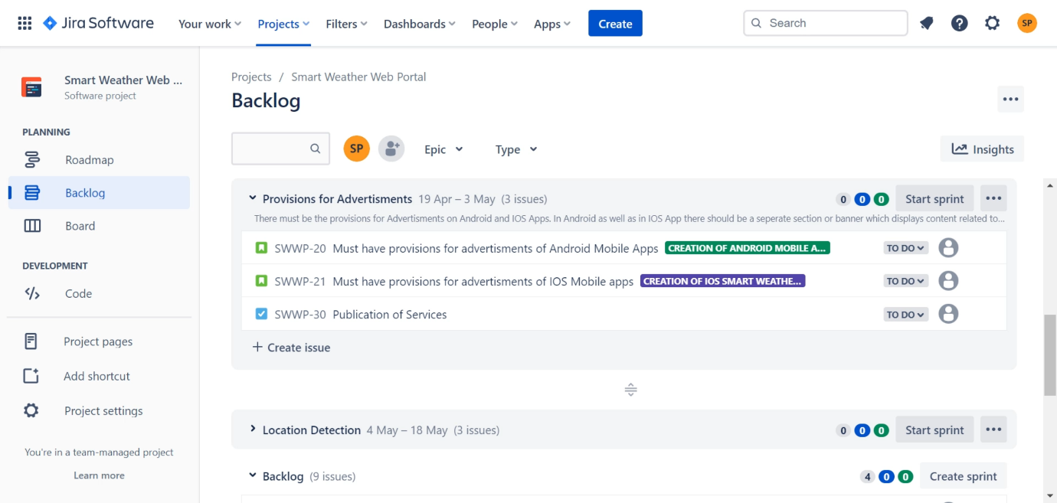

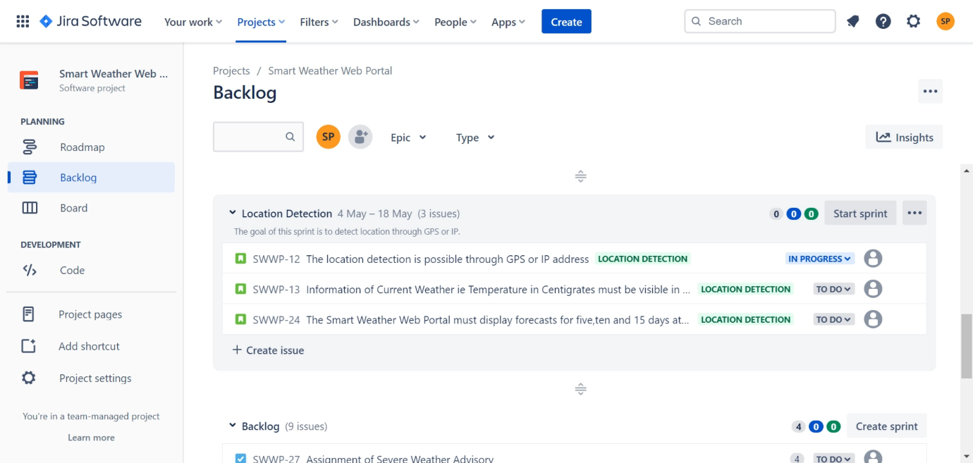

Q5) Start and complete one sprint

Ans) The name of the first sprint is User Registration.It’s start date is 21/03/2023 and its expected date of completion is 2/04/2023.

The below mentioned is the screenshot of first sprint

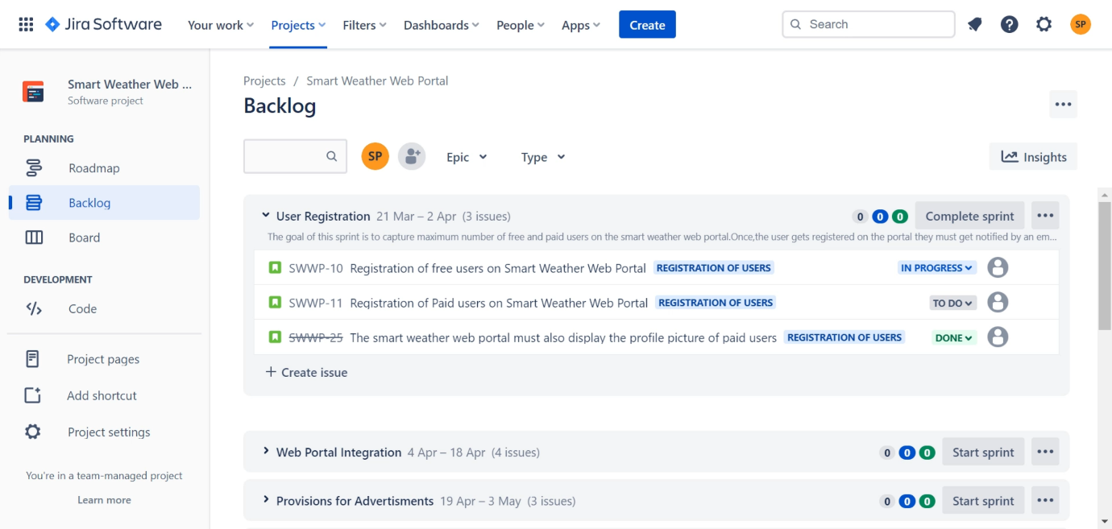

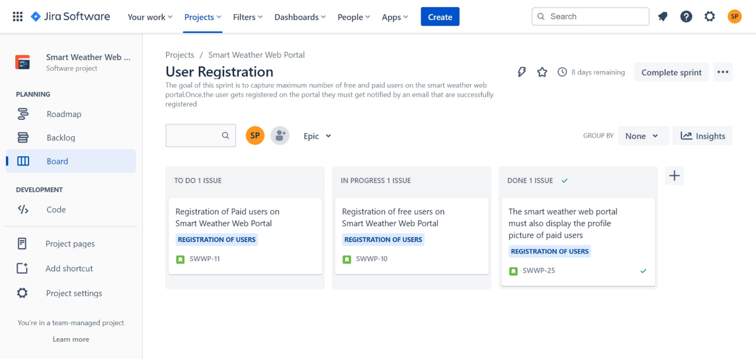

For viewing first sprint click on <https://simplilearns.atlassian.net/jira/software/projects/SWWP/boards/2/backlog>

For viewing the sprint board of first sprint click on

<https://simplilearns.atlassian.net/jira/software/projects/SWWP/boards/2>

Q6) Submit screenshots of: Epics, Backlog,release plan, and Scrum board with tasks in various states.

Ans) The screenshot of Epic is as follows:

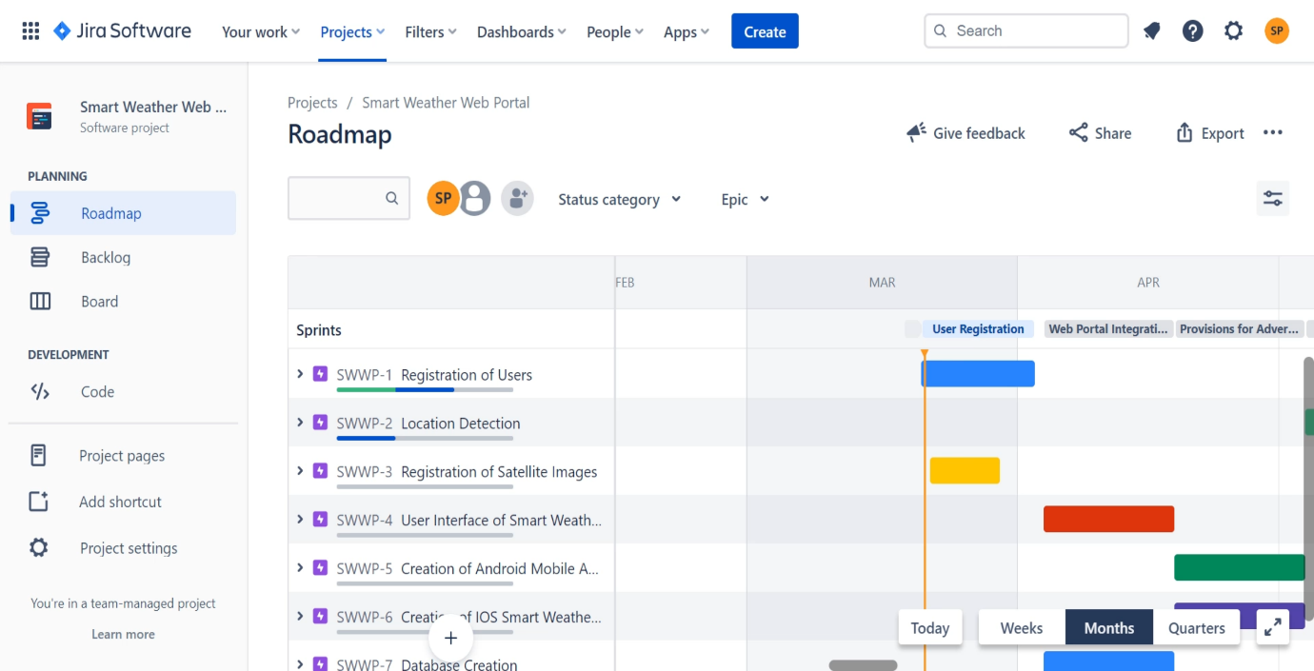

The Screenshot of Backlog is as follows:

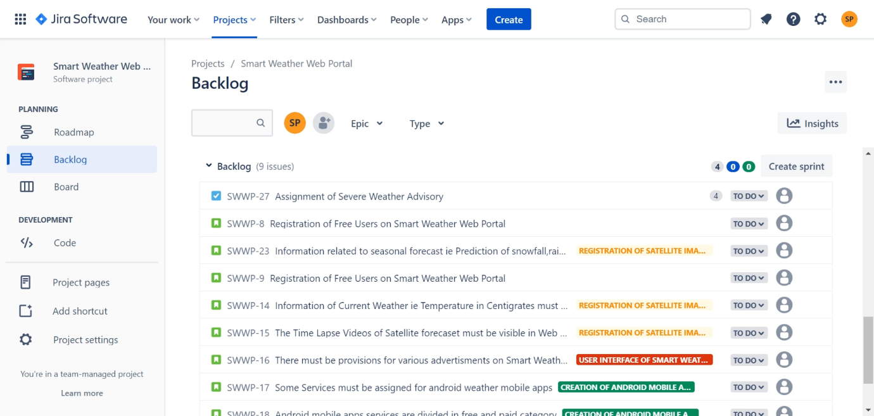

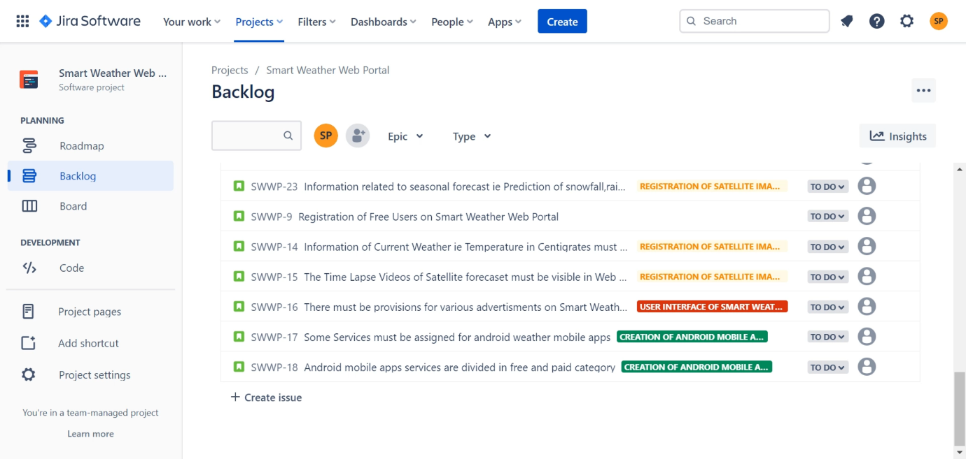

The screenshot of release plan of various sprints is as follows:

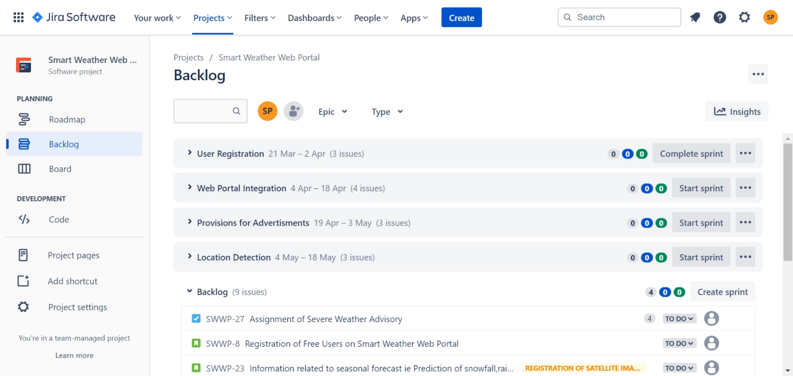

The screenshot of User Registration Sprint in the scrum board is as follows:



For viewing epics click on <https://simplilearns.atlassian.net/jira/software/projects/SWWP/boards/2/roadmap>

For viewing backlog and release plan click on

<https://simplilearns.atlassian.net/jira/software/projects/SWWP/boards/2/backlog>

For viewing scrum board click on

<https://simplilearns.atlassian.net/jira/software/projects/SWWP/boards/2>